dvAgendaSection
ITEM NUMBER dvItemNumberMasked
SUBJECT dvSubjectWithSoftReturns
REFERENCE dvEDMSContainerId - dvFileNumber
REPORT OF dvAuthors

LAND OWNER: Australian Unity Investment Management Administration Pty Ltd

APPLICANT: Investa Office Developments

PURPOSE:

This report seeks Council’s endorsement of a Planning Proposal for the land at 10 Valentine Avenue, Parramatta and that the Planning Proposal be forwarded to the Department of Planning and Environment for a Gateway determination. The report also seeks endorsement to proceed with the preparation of a site-specific Development Control Plan to manage the built form and public domain in association with the Planning Proposal.

RECOMMENDATION

(a) That Council note the recommendation of the Local Planning Panel dated 28 November 2018 in relation to this matter as detailed below, noting that the Panel’s recommendation is consistent with the Council Officer’s recommendation to support the proposal.

(b) That Council endorse the Planning Proposal included at Attachment 2 which seeks to amend the PLEP 2011 by:

- Increasing the FSR on the Floor Space Ratio Map from 6:1 to 10:1;
- Amending the Height of Buildings Map by removing the 54 metres height limit that currently applies to the site;
- Inserting a site-specific clause that exempts office premises from the FSR calculation; and
- Inserting a site-specific clause that prohibits the subdivision of the aboveground car parking;

subject to the inclusion of a site-specific LEP clause that applies the maximum car parking rates endorsed as part of the CBD Planning Proposal.

(c) That Council authorises the CEO to prepare and exhibit a site-specific DCP which provides for a maximum podium height at 25.0 metres AHD in accordance with the existing development consent (DA/841/2017). The DCP should also require the footpath design to be capable of being narrowed if Valentine Avenue is converted to two-way traffic in the future.

(d) That the Planning Proposal be forwarded to the Department of Planning and Environment with a request for a Gateway determination.

(e) That Council advise the Department of Planning and Environment that the CEO will be exercising the plan-making delegations for this Planning Proposal as authorised by Council.

(f) Further, that Council authorises the CEO to correct any minor anomalies of a non-policy and administrative nature that may arise during plan amendment processes.

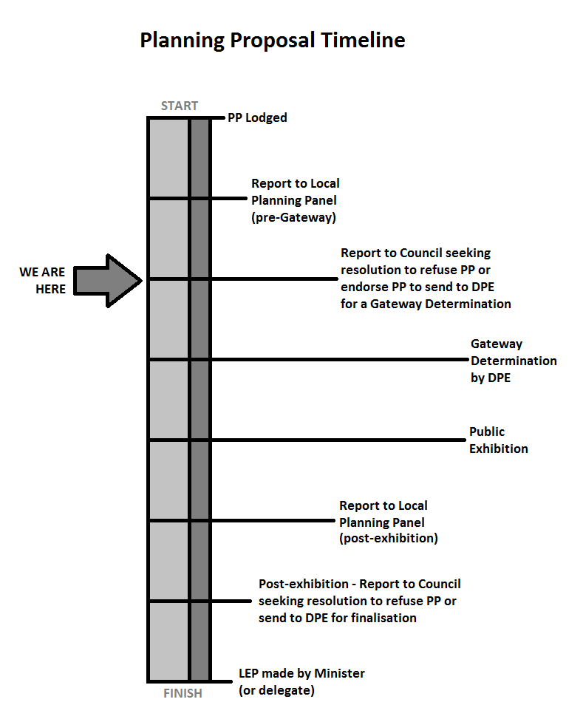

BACKGROUND

- This summary report is supported by a detailed assessment report provided at Attachment 1. The applicant’s Planning Proposal (refer to Attachment 2) seeks to amend the PLEP 2011 by:
  - Increasing the Floor Space ratio (FSR) on the Floor Space Ratio Map from 6:1 to 10:1 (note: the existing Design Excellence provisions provide for additional 15 per cent FSR allowing for a total of 11.5:1);
  - Amending the Height of Buildings (HOB) Map by removing the 54 metres height limit that currently applies to the site;
  - Inserting a site-specific clause that exempts office premises from the FSR calculation; and
  - Inserting a site-specific clause that prohibits the subdivision of the above-ground car parking.
- The site is subject to a previous Design Competition and Development Application. The Planning Proposal is consistent with the CBD Planning Proposal.
- The reference design included with the Planning Proposal, found within the Urban Design Report at Attachment 3, is provided as two separate designs. These reflect the two possible development scenarios that may occur. Reference Design 1 reflects a scenario where the applicant commences building the development approved under the existing consent (DA/841/2017 – which is an approval for a 14-storey commercial building on the part of the site currently containing the carpark structure and adjoining the existing office building) and then applies for a development application for additional storeys permitted under the Planning Proposal. The development would then occur under two consents being the original consent for the lower floors and the second consent for the upper floors.
- Reference Design 2 reflects a scenario where the applicant proposes a new building that has no relationship to the building that is subject to the existing development consent. The application would be a new development application as permitted by the Planning Proposal for the entire building.

ISSUES/OPTIONS/CONSEQUENCES

- The Planning Proposal is consistent with Council’s CBD Planning Proposal in relation to the height and FSR controls. Both Reference Design 1 and 2 are consistent with the position on the podium height reached during the assessment of the previously approved development application (DA/841/2017).
- It is recommended that the Planning Proposal be supported subject to
  - the inclusion of a site-specific clause that applies the maximum car parking rates endorsed as part of the CBD Planning Proposal.
  - the preparation of a site-specific DCP which provides for a maximum podium height at 25.0m AHD in accordance with the existing development consent (DA/841/2017). The DCP should also require the footpath design to be capable of being narrowed to accommodate the conversion of Valentine Avenue to two-way traffic should this be required in the future.

CONSULTATION & TIMING

- Should Council resolve to proceed with the Planning Proposal it will be forwarded to the Department of Planning and Environment for Gateway Determination.

- If a Gateway Determination is received, the Planning Proposal will be placed on public exhibition alongside the site-specific DCP. A report on the outcomes of the public exhibition will be provided to Council addressing any objections received.

FINANCIAL IMPLICATION FOR COUNCIL

- There are no financial implications related to this Planning Proposal and there is no Planning Agreement associated with the Planning Proposal. A Planning Agreement is not required as the site is zoned B3 Commercial Core and residential development is not permissible in the zone. Under Council’s Value Sharing Framework for the Parramatta CBD, commercial developments do not require a Planning Agreement.

Felicity Roberts
Project Officer Land Use Planning

Jonathon Carle
Service Manager Land Use Planning

Jennifer Concato
Manager City Strategy

Mark Leotta
Acting Director Strategic Outcomes and Development

Attachments:
1 | Detailed Assessment Report - Report to Local Planning Panel 28 November 2018 | 15 Pages
2 | Applicant's Planning Proposal | 64 Pages
3 | Applicant's Urban Design Statement | 54 Pages

REFERENCE MATERIAL

